
On Winter Solstice Day!
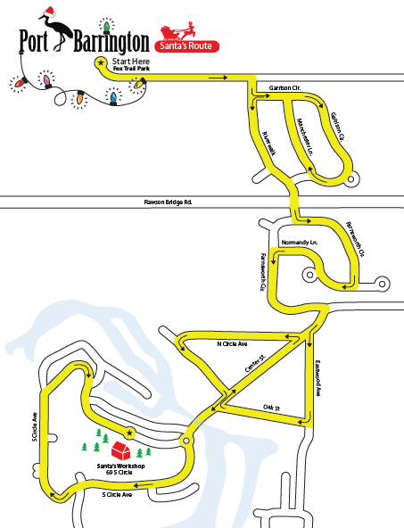


Santa Is Coming to Our Town!
Everything that glitters is NOT necessarily gold! As he arrives for his visit to Port Barrington on Sunday, December 21st, there is sure to be a special twinkle in his eye telling us that appreciating family, friends the beauty of winter in our safe little town is more precious than riches! At approximately 12:30pm Santa plans to leave Fox Trail Park and will wind his way to our Village Hall. See the map for where to line these streets to catch the treats! Then follow the parade to the Village Hall where kids can whisper their wishes to Santa and receive a small gift. Santa arrives at the Village Hall at approximately 1:15 –don’t be late for Santa is a busy fellow! He’d love to have you join him for some hot chocolate and a sweet! Nonperishable food items for the Wauconda Area Food Pantry will be collected in the spirit of the season.

25th Annual House Lighting Contest
A winner will be declared in each
neighborhood during the week of
December 15th as best decked
house!! Winners will be announced
at the 12/21st Santa Party. One house
will be chosen to receive the traveling Blankenship Memorial Décor Award!

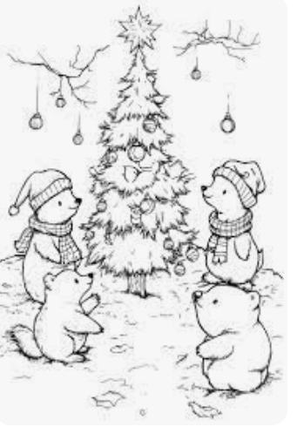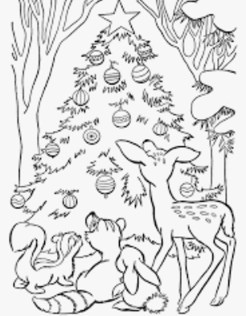

Santa is looking for someone to ride with him in the parade! Color the animals or cut them out to add to your own artwork! Turn them in to the Village Hall by December 17th. The winner will be drawn from entries submitted and will be notified the next day. The lucky winner may choose a parent or friend to also ride along! Please include this info on the back of your artwork: Name____________________Age_________

Address_______________________________
Phone___________Email________________
Christmas Tree Pick-up
Christmas trees can be set out by your curb for pick up by our waste hauler, LRS-Prairieland Recycling & Disposal Services, on regularly scheduled pick up days the first two weeks in January for no added charge. Trees must be free of decorations and must not be bagged.

Holiday Lights Recycling
Right outside the Village Hall is a bin for your zapped, no-good holiday lights and extension cords. Make it on Santa’s “NICE LIST” by keeping them out of the landfills! The bin will be available thru January 2026!



It’s time for our Annual Village Santa Parade & Party on Sunday, December 21st ! Details inside…. Calling all HOAs, Businesses, Residents! You, too, can have an entry in our parade--contact the Village Hall ASAP to let us know. Call the Hall for info!

Holiday surprises of cheer will be distributed by the Village REC Committee. Whether it be a senior neighbor or someone in need of a lift, Please help Santa by contacting the Village Hall by December17th if you know of someone who should be on the list to receive a surprise gift of cheer! Thank you to REC Committee member Patty Bryant for again heading up this project to share some love in our Village.


Annual Snowman Contest will run the entire winter season (ending March 31st, if not before!) Create a snow sculpture in your front yard and call the Village Hall with your address—or submit a picture of your creation with your address attached. villagehall@portbarrington.net
Chili Cook-off Results
Our 30th annual Chili Cook-off was enjoyed by many! Judges from the Broken Oar and Hermannn’s volunteered their discriminating taste buds to determine the best of 20+ entered chilis! Thank you, Judges! This year’s results are:
Best Judged Chili
1st Place Chili………Mike Kopko
2nd Place Chili……...Jen Jurkowski
3rd Place Chili…...…Kristine Russo
People’s Choice Results
Chili….Mike Kopko
The Suzi Gammon Memorial Dessert trophy
was awarded to...... Stephanie Battista
Special thanks to the Broken Oar who brought over a ton of extra chili to enjoy for those still hungry after tasting!
Thank you to Kala Issleb, Jess Lehmann and Jen Jurkowski for co-chairing this event and to our fabulous REC Committee who continues to pull our Community together for fun, friendship and support!
Make way for Santa’s arrival and all winter long! Please be aware that there is no parking on Village roads after snowfall accumulation of 2 inches or more. There is no overnight parking on any Village road and no parking on cul-de-sacs at any time. Remove decorative items from the roadside and keep access to your mailbox clear. To ensure safe driving conditions, please make sure that the snow removed from your driveway is not shoveled, blown or pushed into the roadway. Santa thanks you…so does our Plow Team!

Toys for Tots 
Drop box is at the Village Hall! New, unwrapped toys
will continue to be collected thru December 5th.

Village Port Barrington
69 South Circle Avenue
Port Barrington, Illinois 60010

